11/9/2025
ELEC423 Assignment 1 – MQTT-Based IoT Solution
Machine-to-Machine Communication using Raspberry Pi Pico 2W
"I declare that this assignment is my own work and has been completed in accordance with the University's Academic Integrity Policy. All sources have been appropriately referenced."
Contents
1 Introduction/Background 2
2 Task Implementation 3
2.1 Task 1: Logger Implementation 3
2.2 Task 2: Configuration File Reading 4
2.3 Task 3: Digit Sum Calculation 5
2.4 Task 4: Unix Timestamp 5
2.5 Task 5: WiFi Connection 5
2.6 Task 6: MQTT Subscriber 6
Part I – Connection 6
Part ii – Topic Subscription 6
Part iii – Client ID 6
Part iv – CSV File Creation 6
Part v – Message Parsing & Storage 6
Part vi – LED indication 6
2.7 Task 7: Delay Implementation 6
2.8 Task 8: MQTT Publisher 6
2.9 Task 9: Disconnection 6
3 Conclusions & Discussion 7
4 References 7

Introduction/Background
The Internet of Things (IoT) refers to a network of interconnected devices capable of collecting, exchanging, and processing data autonomously (Atzori, Iera and Morabito, 2010). Machine-to-Machine (M2M) communication is a fundamental subset of IoT, enabling devices to interact and perform tasks without human intervention. The European Telecommunications Standards Institute (ETSI, 2013) has defined an M2M reference architecture that structures these interactions to ensure interoperability and scalability across diverse systems. This architecture is organized into three distinct layers. The device layer includes sensors, actuators, and embedded hardware that gather and act upon physical data. The network layer handles connectivity and communication protocols, bridging devices to application services. Finally, the application layer provides user-facing services, analytics, and control interfaces, enabling the orchestration of smart environments and supporting intelligent decision-making across M2M networks (Sethi and Sarangi, 2017).
Message Queuing Telemetry Transport (MQTT) is a lightweight, publish-subscribe protocol widely adopted in IoT applications due to its efficiency and reliability (Banks and Gupta, 2014). It follows a broker-client architecture where the broker acts as an intermediary, managing message distribution between clients. Clients can function as publishers, sending messages to specific topics, or as subscribers, receiving messages from topics of interest. Topics are hierarchical identifiers that organize data streams, allowing multiple subscribers to receive relevant updates simultaneously. MQTT is particularly suitable for IoT applications because of its minimal bandwidth requirements, low power consumption, and reliable message delivery even in constrained networks (Hunkeler, Truong and Stanford-Clark, 2008). Its Quality of Service (QoS) levels ensure configurable message reliability, making it ideal for real-time monitoring and control of remote devices. This efficiency facilitates seamless M2M communication within complex IoT ecosystems.
The objective of this assignment is to implement a complete IoT solution demonstrating real-time M2M communication. The hardware platform used is the Raspberry Pi Pico 2W (Raspberry Pi Ltd, 2023), a compact wireless-enabled microcontroller ideal for resource-constrained IoT applications. A DHT11 sensor is employed for environmental monitoring, providing temperature and humidity readings at regular intervals. The system is designed to both publish sensor data to an MQTT topic and subscribe to the same topic, demonstrating bidirectional communication and the publish-subscribe pattern. The public Mosquitto broker (Light, 2017) facilitates message distribution, ensuring accessibility and compatibility without requiring custom infrastructure. This assignment highlights the practical integration of embedded hardware, wireless networking, and standardized communication protocols to create a functional IoT system.
The implementation follows a modular design approach, separating functionality into distinct Logger, Publisher, and Subscriber classes to promote code clarity, reusability, and maintainability. Comprehensive error handling is incorporated throughout the system to manage potential failures gracefully, including OSError for hardware and network failures, RuntimeError for MQTT connection issues, and SystemExit for configuration errors requiring graceful termination. The system leverages asynchronous programming via Python's asyncio library, enabling concurrent execution of publishing, subscribing, and logging tasks without blocking the main workflow. This non-blocking approach ensures timely data updates and responsiveness to network events while maintaining system stability. Overall, the solution demonstrates autonomous M2M communication where the Raspberry Pi Pico 2W interacts with the MQTT broker independently, continuously collecting, transmitting, and receiving sensor data in a robust and scalable manner suitable for production IoT deployments.

2 Task Implementation

2.1 Task 1: Logger Implementation
The logger class provides centralized error logging functionality, upon initialization, it checks if ‘error.log’ exists and deletes it to ensure a fresh log file (Fulfils Assignment outline 1). The _create_error_log_file() method creates a new log file with an initial timestamp entry. The _write() method appends error messages with Unix timestamp entry. The _write() method appends error messages with Unix timestamp in the format [TIMESTAMP] ClassName LEVEL: message. The _print() method provides console output for informational messages without writing to file. If lof file creation fails, an OSError is raised to terminal the program, ensuring critical logging failures are handled appropriately.
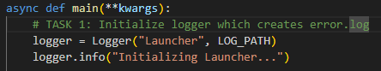
Figure 1 Logger initialization in main

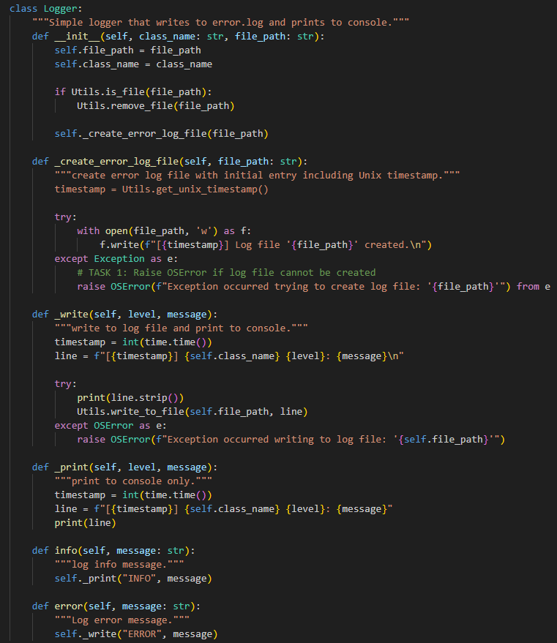
Figure 2 Logger Implementation

Testing Evidence
there one negative case in this initial phase, if there is an invalid path to the log it means we cant create the error.log, therefore we should see the OSError being thrown in the console window and a system termination, since the log file isn’t created at this stage there is no logs to print this message to.
Figure 3: Testing evidence, showing invalid path to logger therefore insuccessful creation of error.log and successful program termination

2.2 Task 2: Configuration File Reading
The extract_launcher_cfg() function validates and reads the 'config.txt' file containing WiFi and MQTT broker credentials. It first checks file existence using Utils.is_file(), raising SystemExit if missing. The function parses each line, splitting on '=' to extract key-value pairs. It validates that all required keys (ACCESS_POINT_NAME, ACCESS_POINT_PASSWORD, MQTT_BROKER_HOSTNAME, MQTT_BROKER_PORT) exist, raising SystemExit with descriptive error messages if any are missing. This approach ensures the program fails gracefully with clear diagnostics rather than encountering runtime errors during connection attempts, therefore this task fulfils the assignment outline task 2.
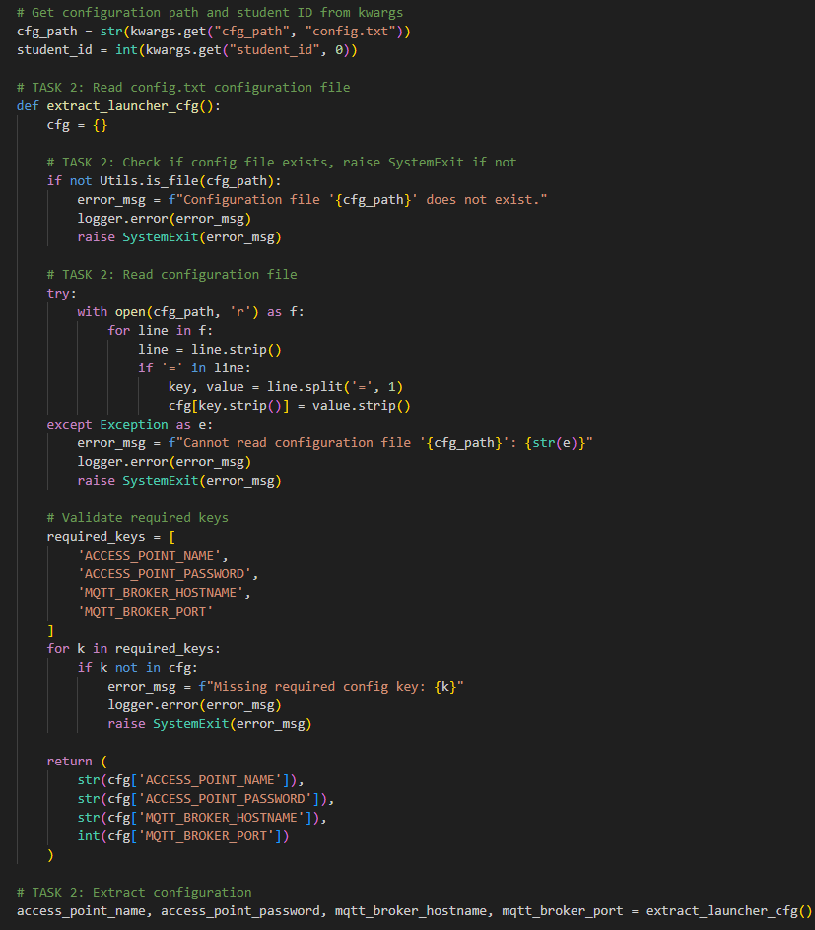
Figure 4 code above retrieves config file path from main kwargs and extracts the AP and MQTT connection information we need, if cfg file does not exist we raise a System Exception an utilizing the logger we log an error.
Testing Evidence
one invalid test being when confif is not shown, therefore, so I change the CGG path to something that does not exist therefore the system error should be thrown and the proper error should be logged in error.txt

Test Case 2 shows that when something is missing from the configuration file in this case whe WAP host name a Valid System Exit Exception is thrown and the exception is printed to the logger.
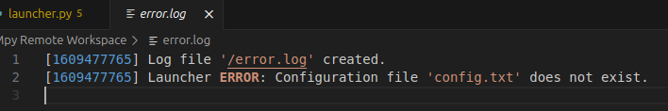Figure 5: testing evidence showing that when configuration path given is invalid valid logs are printed to the error.log and system terminates.

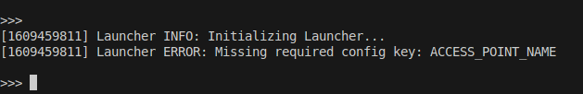Figure 6: shows the terminal output
Figure 7: shows the error.log output

2.3 Task 3: Digit Sum Calculation
The digit sum calculation uses Python's built-in functions to sum individual digits of the student ID. The expression sum(int(d) for d in str(student_id)) converts the numeric ID to a string, iterates through each character, converts back to integer, and sums the results. For student ID 201954749, this yields 2+0+1+9+5+4+7+4+9 = 41. This value is included in every published MQTT message as a unique identifier.
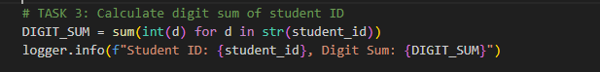Figure 8: shows the implmenetation of the conversion of student number to digit sum

2.4 Task 4: Unix Timestamp
The Utils.get_unix_timestamp() method retrieves the current Unix timestamp using time.time(), which returns seconds since January 1, 1970 (Unix epoch). This timestamp is stored in the UNIX_TS variable and used throughout the program for topic naming, client ID generation, and message payloads, ensuring temporal consistency across all operations initiated in the same execution
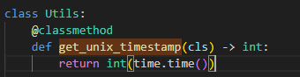Figure 9: shows the utility function for getting the unix timestamp

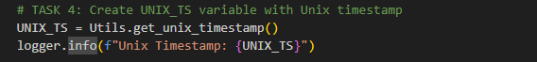Figure 10: shows the main code for utilitizing the utility for getting the UNIX_TS

2.5 Task 5: WiFi Connection
The Utils.connect_wifi() method establishes WiFi connectivity using MicroPython's network module. It activates the station interface, initiates connection with provided credentials, and implements a timeout mechanism. The method polls wlan.isconnected() every 0.5 seconds, tracking elapsed time. If 20 seconds elapse without successful connection, an OSError is raised. Upon success, the MAC address is retrieved using wlan.config('mac') and formatted as a 12-character hexadecimal string (without colons) for MQTT topic construction.
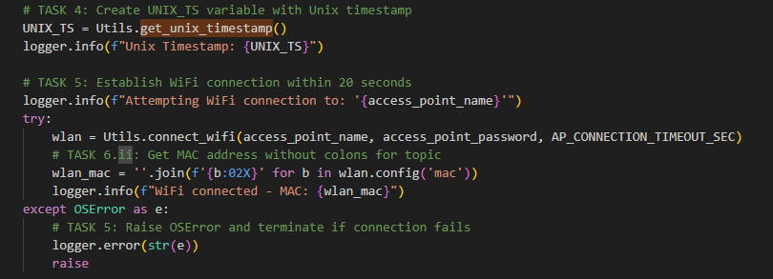
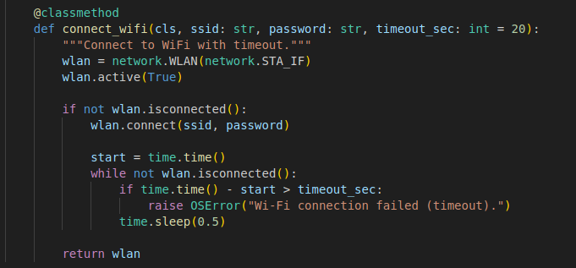
Testing evidence:
if you can’t connect there should be an os error thrown and a valid exception message thrown, for example have an incorrect romroad password after 15 seconds OSError should be thrown and this exception should be logged.
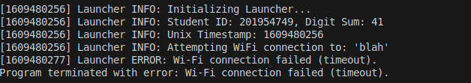
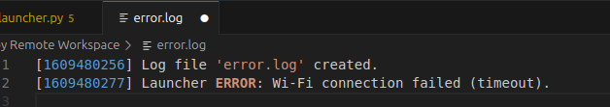

2.6 Task 6: MQTT Subscriber

Part I – Connection
The DHTMQTTSubscriber class establishes an MQTT connection using the umqtt.simple2 library. A MQTTClient instance is created with a unique client ID following the format BOARD_ID-UNIX_TS-sub, where BOARD_ID is derived from machine.unique_id(). The connect() method is called within a try-except block; if connection fails, a RuntimeError is raised to terminate the program gracefully with appropriate error logging.
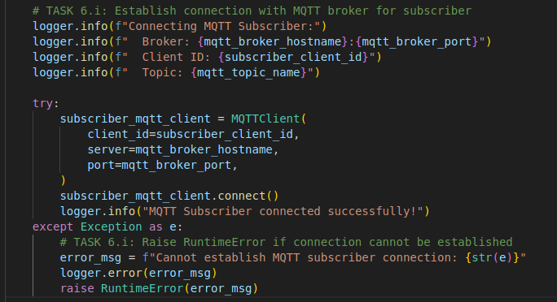

Testing evidence

Part ii – Topic Subscription
The topic follows the hierarchical structure /sensor/MAC_WLAN/UNIX_TS/, incorporating the WiFi MAC address (without colons) and the Unix timestamp. This ensures topic uniqueness for each execution. The subscribe() method registers interest in this topic, and set_callback() links the _on_msg_rcv_cb() method to handle incoming messages.

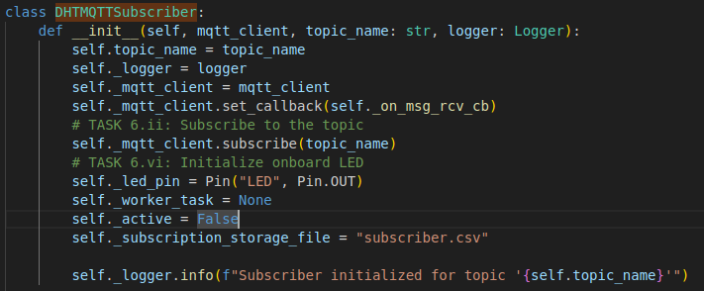

Part iii

– Client ID
The subscriber client ID format BOARD_ID-UNIX_TS-sub ensures uniqueness across multiple devices and execution instances. The board ID provides device-level uniqueness, the timestamp provides temporal uniqueness, and the '-sub' suffix distinguishes it from the publisher client.

Part iv – CSV File Creation
The _create_subscriber_csv() method checks for existing 'subscriber.csv' using Utils.is_file(). Only if absent does it create a new file with the header 'UNIX_TS, C, %'. This prevents overwriting existing data from previous runs while ensuring the file structure is initialized correctly for new executions.
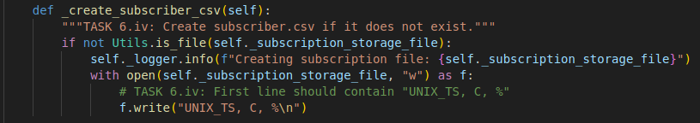

Part v – Message Parsing & Storage
The _on_msg_rcv_cb() callback is invoked automatically when messages arrive. It decodes the byte payload to UTF-8 string, splits on commas to extract components, and strips whitespace and unit labels ('C', '%'). The extracted Unix timestamp, temperature, and humidity values are appended to the CSV file in the format 'UNIX_TS, TEMP, HUMIDITY', maintaining a persistent record of all received sensor readings.
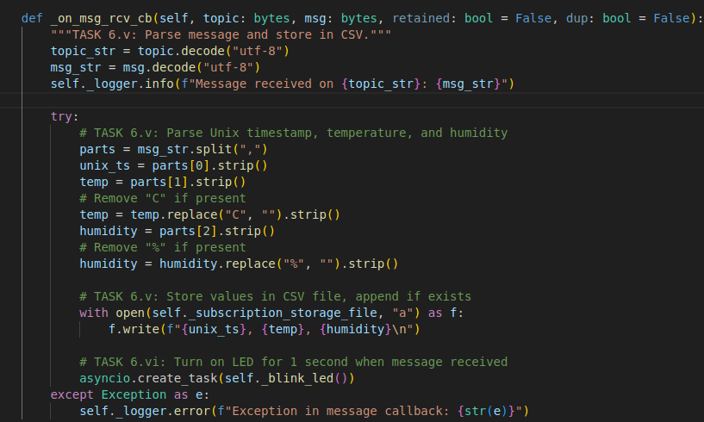

Part vi – LED indication
The onboard LED (Pin 'LED') provides visual feedback for message reception. The _blink_led() asynchronous coroutine sets the LED high for 1 second using asyncio.sleep(), then sets it low. Using asyncio.create_task() ensures the LED operation doesn't block message processing, allowing the subscriber to remain responsive to rapid message arrival, video of this in action show in appendix 2.
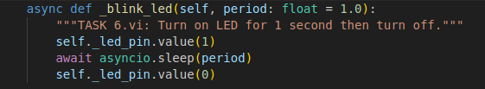

2.7 Task 7: Delay Implementation
An asynchronous delay of 15 seconds is implemented using await asyncio.sleep(15.0). This non-blocking delay allows the subscriber to become fully operational and receive its first messages before the publisher begins transmission. Using asyncio.sleep() rather than time.sleep() ensures the event loop remains responsive and the subscriber's background worker continues processing messages during this waiting period.
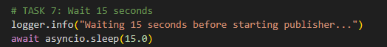

2.8 Task 8: MQTT Publisher

Part I – Connection
The DHTMQTTPublisher establishes a separate MQTT connection using a distinct client ID (BOARD_ID-UNIX_TS-pub). This separate connection is essential as MQTT brokers typically don't allow the same client ID to maintain multiple simultaneous connections. The connection process mirrors the subscriber, raising RuntimeError on failure.
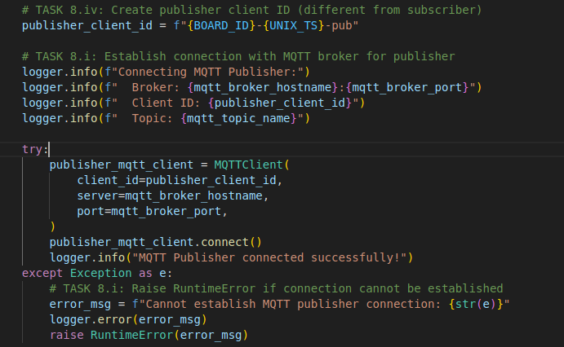

Part ii – Topic
The publisher uses the identical topic as the subscriber (/sensor/MAC_WLAN/UNIX_TS/), enabling the device to receive its own published messages. This loopback configuration demonstrates the pub-sub pattern and allows verification that published data successfully traverses the MQTT broker.

Part iii – Sensor Reading & Message Format
The _read_dht_sensor() method implements robust sensor reading with retry logic. DHT11 sensors occasionally return invalid readings; therefore, the method attempts measurement up to 10 times with 0.5-second intervals. After successful reading, the message is formatted as 'UNIX_TS, TEMP, C, HUM, %, DIGIT_SUM', including the calculated digit sum for identification. If all attempts fail, an OSError is raised to prevent publishing invalid data.

Part iv – Client ID
The publisher client ID follows the format BOARD_ID-UNIX_TS-pub, differing from the subscriber only in the suffix. This allows the same device to maintain two distinct MQTT sessions simultaneously while remaining traceable to the same physical device through the shared BOARD_ID.

Part v – Publishing Interval
The _publisher_worker() coroutine implements the publishing loop using asyncio.sleep(15.0) to achieve 15-second intervals. Each iteration reads the sensor, constructs the payload, publishes to the broker, and logs the action. The asynchronous approach allows the subscriber to continue processing received messages concurrently without blocking.
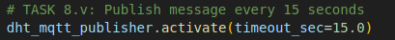

Testing Evidence

2.9 Task 9: Disconnection
After 5 minutes (300 seconds) of operation, the program initiates graceful shutdown. The deactivate() methods set the _active flags to False, causing the publisher and subscriber worker coroutines to exit their while loops. The worker tasks are then cancelled using cancel(). Finally, disconnect() is called on both MQTT clients to close the TCP connections to the broker cleanly, preventing resource leaks and ensuring proper connection termination on the broker side.
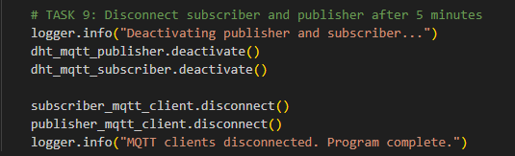

3 Conclusions & Discussion
This assignment successfully implemented a complete IoT solution demonstrating autonomous M2M communication using the MQTT protocol. The implementation achieved all specified objectives: error logging, configuration management, WiFi connectivity, MQTT publish-subscribe communication, sensor data acquisition, and graceful shutdown. The modular design using separate classes for logging, publishing, and subscribing enhanced code maintainability and clarity.
Several aspects of the implementation proved particularly effective. The asynchronous design using asyncio allowed concurrent publisher and subscriber operations without blocking. The retry mechanism for DHT11 sensor readings handled intermittent sensor failures gracefully. The comprehensive error handling with specific exception types (OSError, RuntimeError, SystemExit) provided clear diagnostic information. The CSV file append mechanism successfully preserved data across potential re-runs while preventing duplication.
The primary challenge was ensuring the subscriber could handle messages while the publisher was simultaneously sending. This was resolved through asyncio's cooperative multitasking, where await statements yield control between tasks. Another challenge was formatting the MQTT topic and client IDs correctly with MAC address and timestamps; careful string formatting and testing ensured compliance. DHT11 sensor reliability required implementing the 10-attempt retry mechanism to handle occasional read failures.
Comprehensive testing verified each task incrementally. WiFi connection was tested first to ensure network availability. The subscriber was tested using MQTT Explorer (or similar) to manually publish test messages before implementing the publisher. Sensor reading was tested independently before integration. The complete system was run for the full 5 minutes multiple times to verify stability and correct 15-second publishing intervals. CSV file contents were manually inspected to confirm data integrity and correct formatting.
Future enhancements could include implementing Quality of Service (QoS) levels for guaranteed message delivery. Adding reconnection logic would improve robustness if WiFi or MQTT connections drop. Implementing circular buffering for the CSV file would prevent unlimited file growth in long-running deployments. Adding configuration options for publishing intervals and sensor types would increase flexibility. Implementing MQTT TLS encryption would enhance security for production deployments, though this requires certificates and a different broker configuration.

4 References
Atzori, L., Iera, A. and Morabito, G. (2010) 'The Internet of Things: A survey', Computer Networks, 54(15), pp. 2787-2805. doi: 10.1016/j.comnet.2010.05.010.
Banks, A. and Gupta, R. (2014) MQTT Version 3.1.1. OASIS Standard. Available at: http://docs.oasis-open.org/mqtt/mqtt/v3.1.1/os/mqtt-v3.1.1-os.html (Accessed: 8 November 2025).
European Telecommunications Standards Institute (ETSI) (2013) Machine-to-Machine communications (M2M); Functional architecture (ETSI TS 102 690 V2.1.1). Sophia Antipolis: ETSI.
Hunkeler, U., Truong, H.L. and Stanford-Clark, A. (2008) 'MQTT-S — A publish/subscribe protocol for Wireless Sensor Networks', in 2008 3rd International Conference on Communication Systems Software and Middleware and Workshops (COMSWARE '08). Bangalore, India, 6-10 January, pp. 791-798. doi: 10.1109/COMSW.2008.4554519.
Light, R.A. (2017) 'Mosquitto: server and client implementation of the MQTT protocol', Journal of Open Source Software, 2(13), p. 265. doi: 10.21105/joss.00265.
Raspberry Pi Ltd (2023) Raspberry Pi Pico W Datasheet. Cambridge: Raspberry Pi Ltd. Available at: https://datasheets.raspberrypi.com/picow/pico-w-datasheet.pdf (Accessed: 8 November 2025).
Sethi, P. and Sarangi, S.R. (2017) 'Internet of Things: Architectures, Protocols, and Applications', Journal of Electrical and Computer Engineering, 2017, pp. 1-25. doi: 10.1155/2017/9324035.
Appendix A: Full Desktop Screenshots

5 Appendix
Appendix A: Video showing IoT mmqt pub/sub in operation
https://youtu.be/WOvxQpb_93c

Appendix B: Video showing IoT Video showing raspberry pi blinking reacting to messages being received
https://youtu.be/mIiatjo1yaA

Appendix C: Subscriber.csv on 5 minute valid test
UNIX_TS, C, %
1609468206, 24, C
1609468221, 24, C
1609468236, 24, C
1609468251, 25, C
1609468267, 25, C
1609468282, 25, C
1609468297, 25, C
1609468312, 25, C
1609468328, 25, C
1609468343, 25, C
1609468358, 25, C
1609468374, 26, C
1609468389, 27, C
1609468404, 27, C
1609468419, 27, C
1609468435, 26, C
1609468450, 26, C
1609468465, 26, C
1609468481, 26, C
1609468496, 26, C
1609477743, 26, C
1609477970, 23, C
1609478030, 23, C
1609478046, 23, C
1609478061, 23, C
1609478076, 23, C
1609478091, 23, C
1609478107, 23, C
1609478122, 23, C
1609478137, 23, C
1609478153, 23, C
1609478168, 23, C

